Book Manager

Using a Agile Methodologies

By :

Angrej Singh

Jagdeep Singh

Arshdeep Kaur

Introduction 3

Agile Methodology 3

Wireframes 3

Login Page 3

Registration Page 4

Main Page 5

Add Page 5

Book Detail Page 6

Record Page 6

Borrow Page 7

Mockups 7

Login Page 7

Registartion Page 8

Main Page 8

Add Page 9

Book Detail Page 9

Record Page 10

Borrow Page 10

Testing 11

**Functional Testing** 11

Conclusion and Future Work 12

# Introduction

This project is about the Book Manager application created by a group of 3 people. The application works in different ways. There is listing books, search option and curd operation. At the starting of the application, there is login option and registration of new user.

# 

# Agile Methodology

In this project, the Agile approach is being used as an alternative to conventional methods. This strategic approach is highly successful and realistic, and addresses the technology's evolving needs.

Our group has used the agile / scrum methodology in this project. At first, all requirements are specified and fulfilled by the team members. The team then decided to implement the Book Manager application's special feature to suit the users ' needs.

There's been a lot of changes to make this software more user friendly. The software is available for users to use after all the updates have been developed.

# 

# Team Member Role

Arshdeep Kaur : Product Owner

Angrej Singh : Srum Master

Jagdeep Singh : Stakeholder

# Wireframes

## Login Page

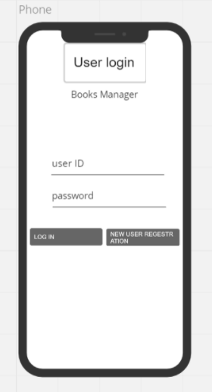

## Registration Page

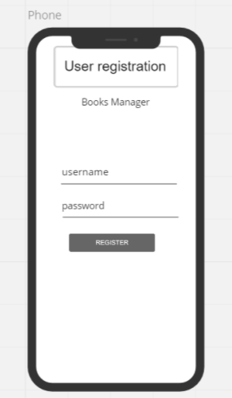

## Main Page

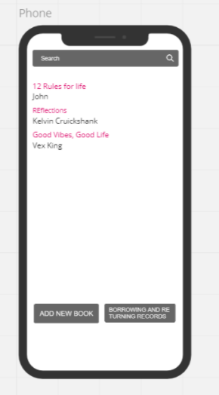

## Add Page

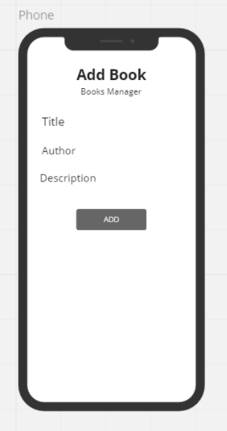

## Book Detail Page

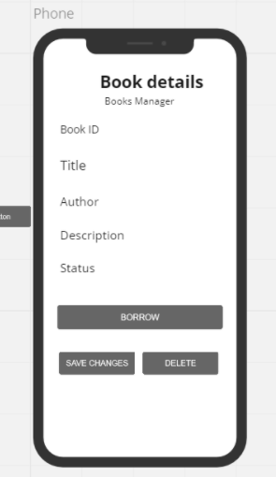

## Record Page

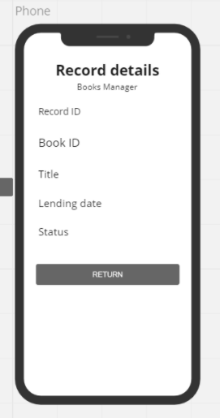

## Borrow Page

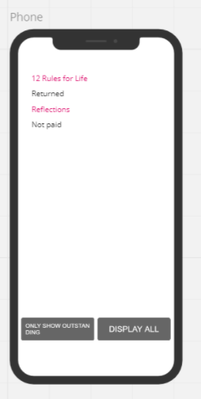

# Mockups

## Login Page

## 

## Registartion Page

## Main Page

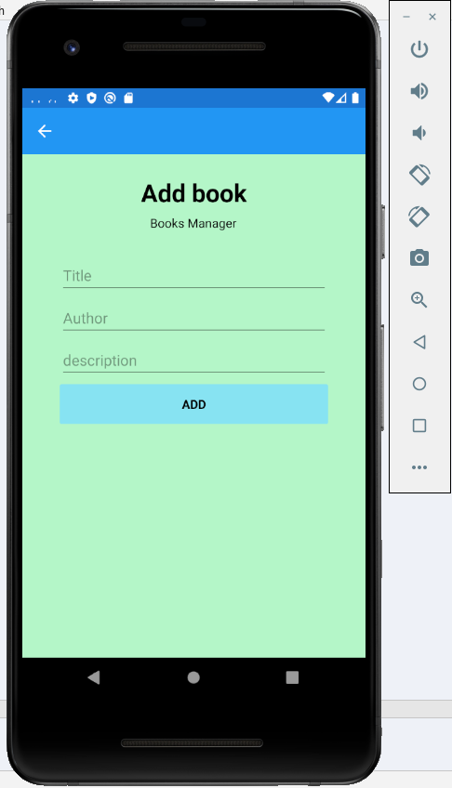

## Add Page

## Book Detail Page

## Record Page

## Borrow Page

# Testing

For this project, we just conducted the usability and functional testing out of which you can found Usability Testing.xls, in different folder and functional testing is mentioned below.

## **Functional Testing**

|  |  |  |  |  |  |
| --- | --- | --- | --- | --- | --- |
| **Step NO** | **Test Step** | **Input Data** | **Expected Result** | **Actual Result** | **Test Step Result** |
| 1 | Can Change the detail of book | Put any information | Detail Should be updated | As Expected | Pass |
| 2 | Click on Search Button | Put name of book | Result appear on same screen | As Expected | Pass |
| 3 | Click on Add Button | Put all information of book | All Details About the will add into Main Page | As Expected | Pass |
| 4 | Click on any book | Borrow option will appear | A new page should appear  On the Screen | As Expected | Pass |
| 5 | Login Button | Put Login detail | All the details of user will matches | As Expected | Pass |
| 6 | Registration  Button | Fill new user info | Successfully added into database | As Expected | Pass |

# 

# Conclusion and Future Work

In short, this project is built on an agile scrum approach in which the IT group has developed the so-called Book Manager application. Due to the limited time, we just build a small application. However, this application can be improved further, and more features can be added. like, online search option and payement etc.